Report guide
Overview of report functionality

Content

- High level overview of reporting functionality

2.0 Rights and Roles

3.0 Accessing Talentlink

4.0 Standard reports

5.0 Analytical reports

6.0 Ad-hoc reports

7.0 Reporting apps

1.0 High level overview

The following types of report are available:

Standard reports:
  - My reports - accessible for all users.
  - Our reports - accessible only for users with special rights to launch our reports.

Standard reports are predetermined by Lumesse but provide an opportunity to filter and drill down to gather further information.

Advanced reports (configurable reports):
  - Live Listings - accessible for users with special rights to launch live listings.
  - Analytical Reports - accessible for users with special rights to launch analytical reports.
  - Ad hoc reports (customised reports for each user).

Standard and advanced report data can be exported in Excel or PDF format.
Ad hoc reports can be generated in HTML, Excel or CSV format.

Please note:

Standard and Analytical reports do not reflect the live database. Tables for these types of reports are refreshed once a week, during the weekend. Changes made in the database register in reports run the following week.

Live Listing and Ad hoc Reports reflect the live database. Changes immediately register in the reports.

2.0 Overview

The following roles are required to access the various reports functionality. Super users should consider what access users require and update the roles to grant access.

Role | Purpose
View diversity information in candidate file | To access equal opportunities data
Access to reporting apps & Manage homepage – configurable apps | To create reporting apps
Access to live listing | To access and run reports for live job postings, job openings and applications
Access to my reports | Generate reports for jobs you are added to
Access to our reports | Generate reports for information in the organisation level you have access to
Access to ad-hoc reports | Ability to access to create and schedule report templates
Manage tags | To create named tags for ad-hoc reports to support a filing system for template reports created.

3.0 Accessing Talentlink

Step 1: Navigate to the Talentlink system using

https://emea3.mrtedtalentlink.com or https://global3.mrtedtalentlink.com.

Step 2: Enter log in credentials provided to you by either your super user or Talentlink trainer.
Ensure you use the name of WM Jobs

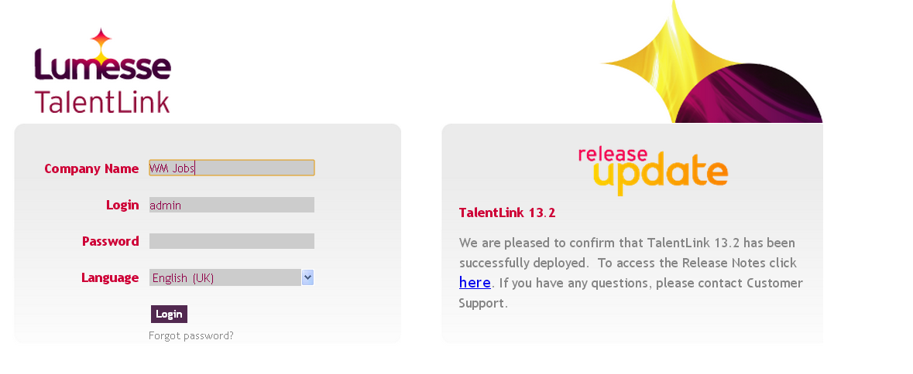

4.0 Standard reports
4.1 This brief guide summarises the steps users need to take to generate standard reports functionality.

Step 1: Once logging into Talentlink then navigate to the left hand toggle menu. Once clicked you will then see it expands as below.

Step 2: Select the option called “Reporting” by clicking the plus icon next to the word. Then select standard and analytics.

Step 3: This will expand to show standard reporting titles to choose from.

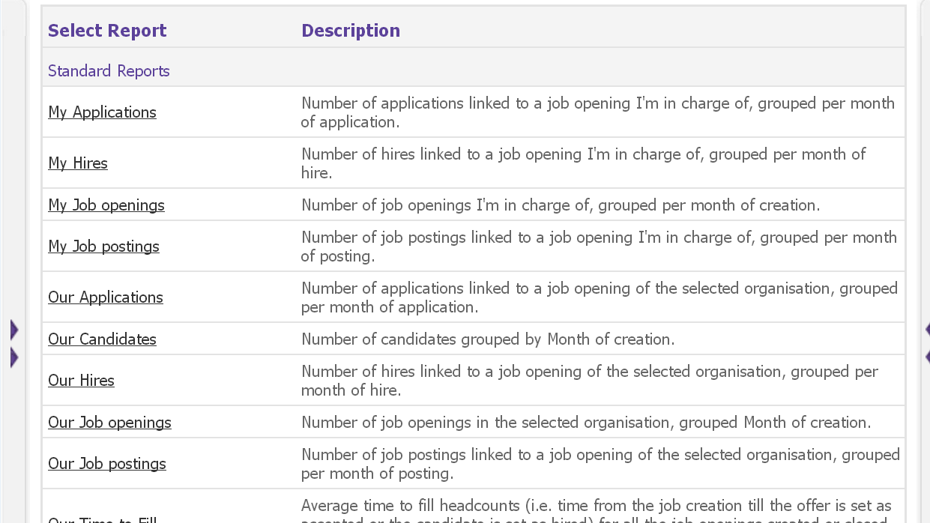

Step 4: Select the report title you wish to view and you will then see consolidation dimensions to access. This means the data you want to be included within the report. Select the dimension to be used and click ok.

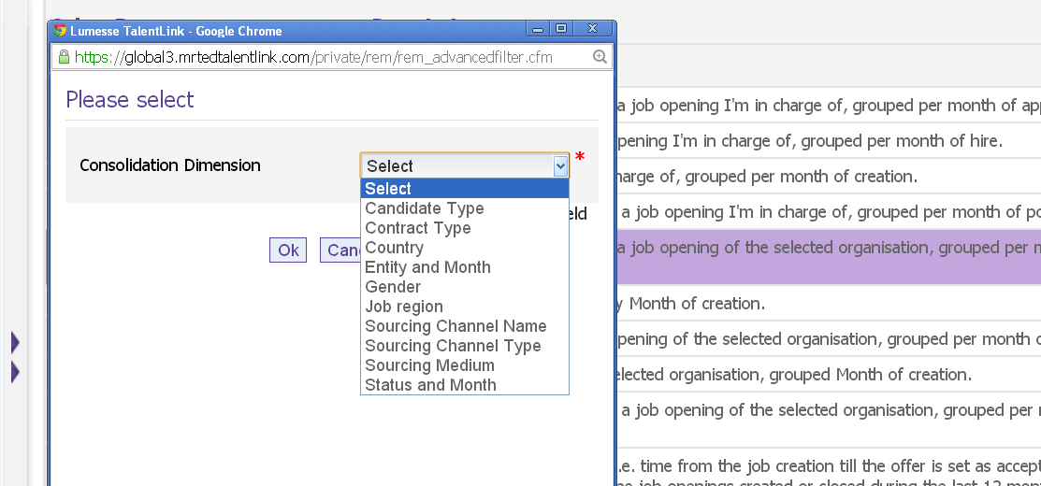.

Step 5: Once you have selected this then a new window will open. The first appears in graphical format. This is page 1 of 2.

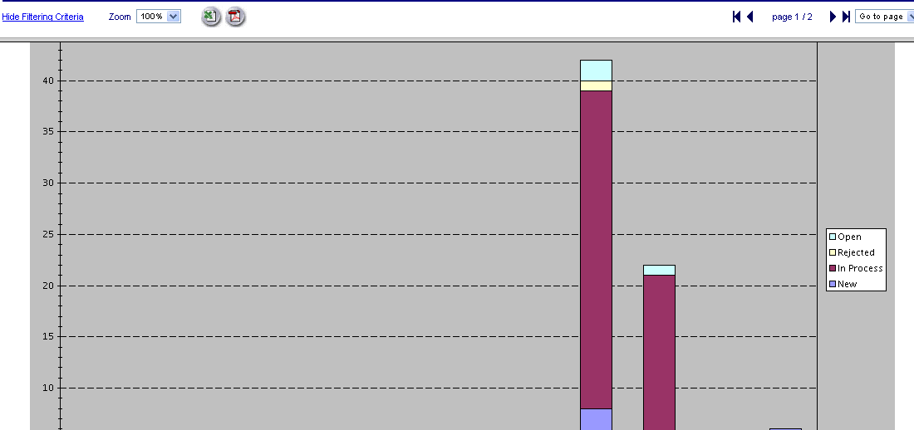

Step 6: When you select the second page you will then see a summary of data (volume and %).

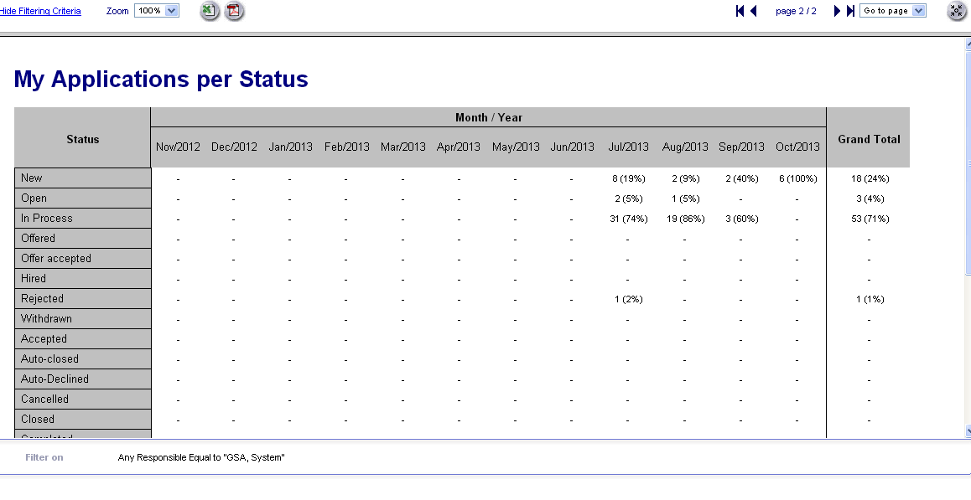

Step 7: If you wish to extract the data this can be extracted in excel or PDF format.

5.0 Analytical reports

This brief guide summarises the steps users need to take to generate analytical reports functionality.

Step 1: Once logging into Talentlink then navigate to the left hand toggle menu. Once clicked you will then see it expands as below.

Step 2: Select the option called “Reporting” by clicking the plus icon next to the word. Then select standard and analytics.

Step 3: You will then see the pre set analytic reports available.

Step 4: Because you are accessing wider information relating to your organisation then you will next see that there are additional filters which can be used to refine the report. Fields with a red asterisk are mandatory fields.

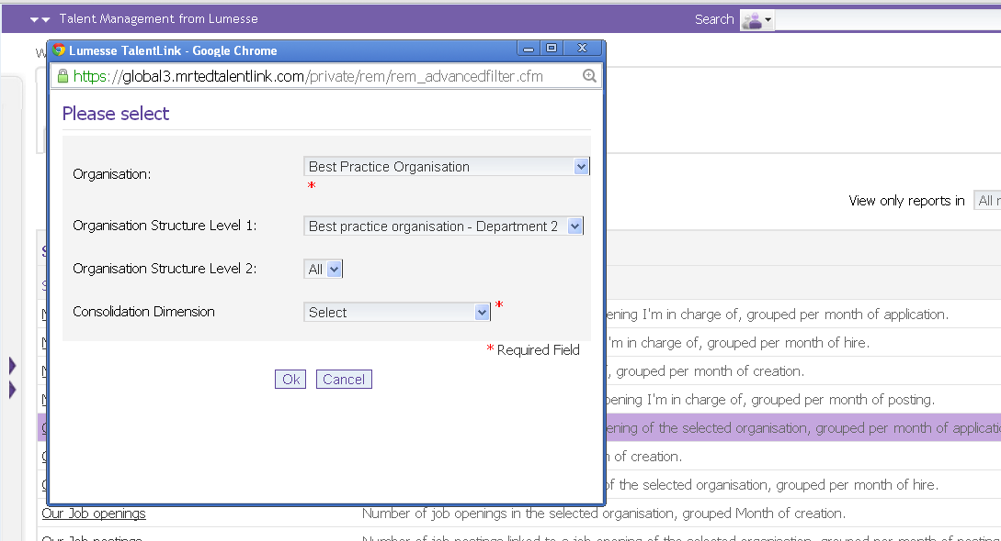
Step 5: Once you have selected the required filters then a new window will open. The first appears in graphical format. This is page 1 of 2.

Step 6: When you select the second page you will then see a summary of data (volume and %).

Step 7: If you wish to extract the data this can be extracted in excel or PDF format.

6.0 Ad-hoc reports

Ad-hoc reporting enables users to provide much more detail in reports and can drill down to further information required. Raw data can be gained which can be manipulated as required.

Step1: Navigate to the left hand toggle menu> select reporting > select adhoc reports.

Step 2: You will see there is a tab called Adhoc reports. Click on the chevron icon and select create report.

Step 3: You will have an opportunity to name the report and identify dimensions for this. You will then have options to select which reporting element is required from applications, job opening, sessions and contract/hires.
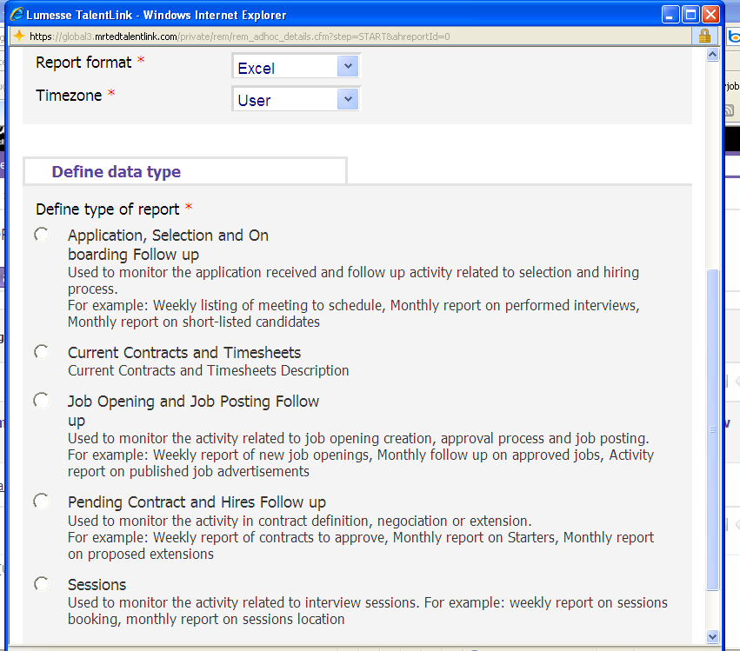
Step 4: Once you have selected the report required and pressed ok. You are then navigated through a reporting wizard.
Columns – this enables you to select the data you want to include in the report.

Within columns tab you will see options within “select domain”.

i.e. Application data, Job Content data etc.

The columns can then be set into the relevant order.

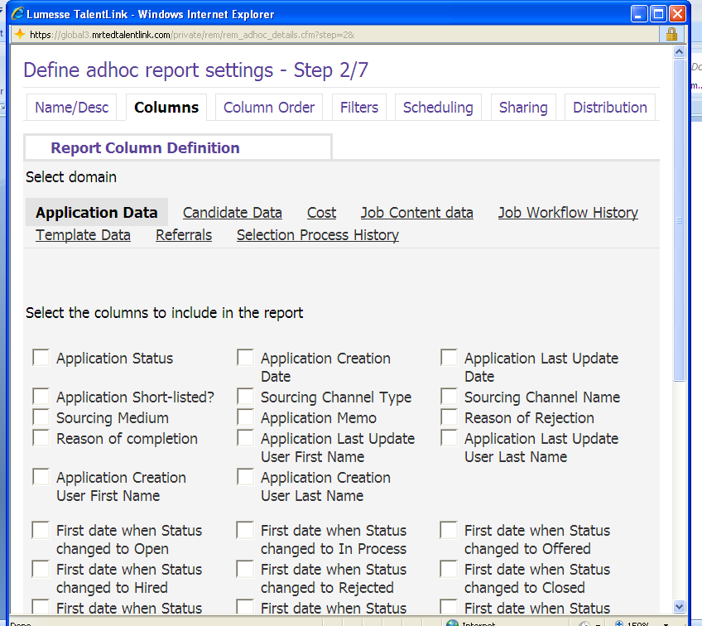
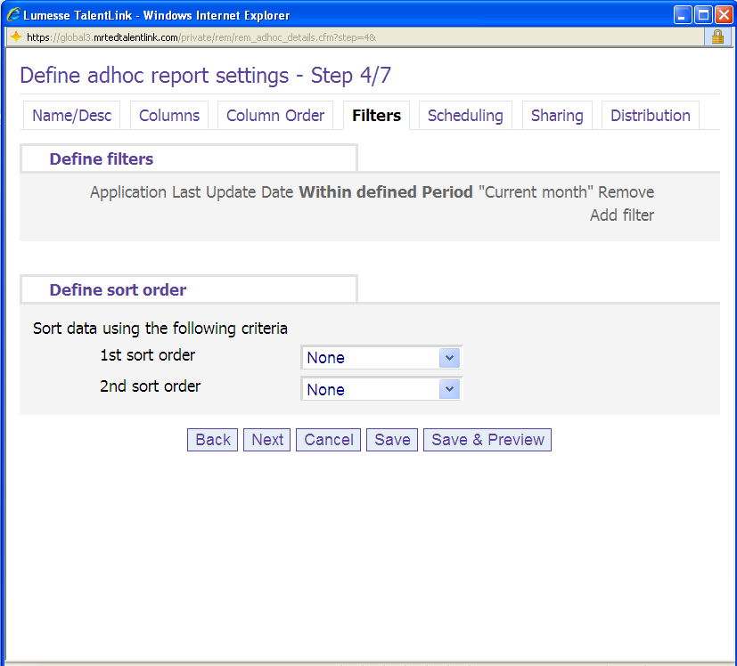
Filters can be applied to restrict the data required i.e. to filter by time period, application status.

Select add filter.

The filters can then be defined using the relevant domain/field.

Note; In order to filter against the domain then the value does need to be included as a column within your report in the first place.

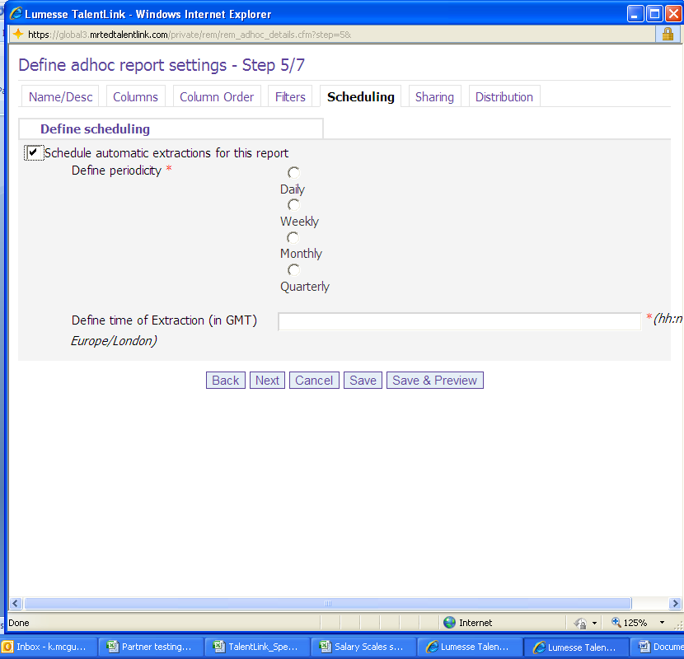
Sharing a document enables you to see a list of users in which you will want them to have access to your report.

Reports can be scheduled to extract on a pre defined basis. This extraction of the report can then be distributed to relevant Talent users and will be sent as per the extraction time given.

The distribution list enables you to select the Talentlink user you wish to send the scheduled report to.

7.0 Reporting apps
Available on the home page for individuals who have the rights to access apps

Users can create a reporting specific workspace meaning if the individual only needs to see reporting information I.e. number of jobs/applications or if a recruiter is responsible for “housekeeping” and monitoring candidate management then a specific workspace will be useful.
Apps can be used within the workspace and drill down to what the user needs to see. Example apps are:
- Applicant inflow
- Applications by stage
- Cost per hire
- Diversity analysis
- Jobs aging
- Live listing of candidates, applications, postings
- My applications, hires, jobs posting
- Our applications, postings
- Our time to fill

