Creating Contracts without VBS
Guidance

Contents
Overview 2
What’s changed? 2
How does it work? 3
Amending contracts 6

Overview
For those of you currently using the Contracts functionality within TalentLink, you will know that running a contract requires you to download a VBS file (visual basic script file) and access a copy of a candidate’s contract outside the system through this means.
To ensure you have the latest features and functionality, the ability to create contracts with VBS will be removed and you will now have the ability to generate contracts directly in TalentLink.
What’s changed?
When writing a contract inside TalentLink, you will now have two options available to you as the recruiter:
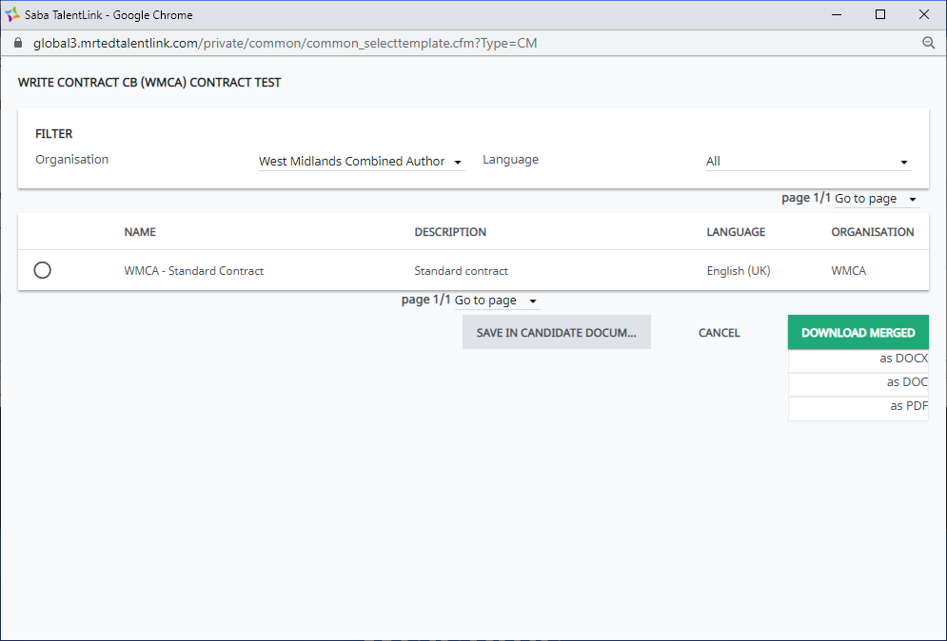
Save in Candidate Documents
This allows you to save a copy of the generated contract directly to a candidate’s documents/candidate’s pools tab, meaning, this it is easily accessible when attaching a contract for a candidate to a communication sent from the system.
By hovering over the button inside of TalentLink, this gives you the ability to preview the contract before saving it and, saving a copy to a local drive if needs be:
Download Merged
Here, you are available to download a copy of the relevant contract if you wish to make changes. You are able to download one of three versions:
DOCX – you can download a Word document – this is the current default Word format, which can be converted to DOC files. If you wish to download a Word version of a contract, we recommend that you use this option.
DOC – this will be downloaded as a Word document, which is an older file format version of Word than DOCX
PDF – you can easily download a copy of the contract in a PDF version.

How does it work?
Writing a contract from TalentLink works in the same way, where you would navigate to the Hiring Process tab for a candidate, and select ‘Write Contract’:
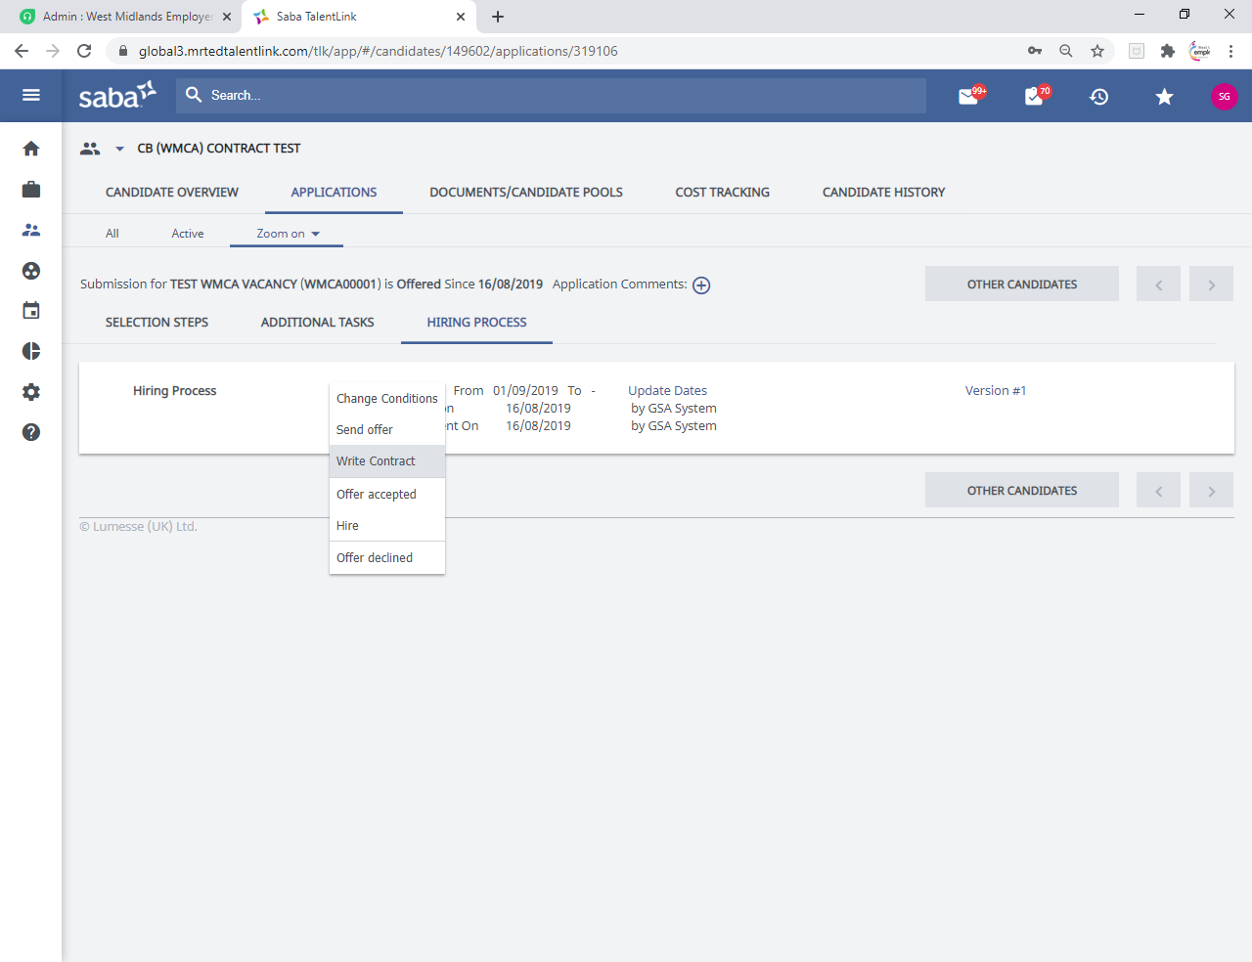
You will then select the relevant contract template and simply use one of the two new options available to you:
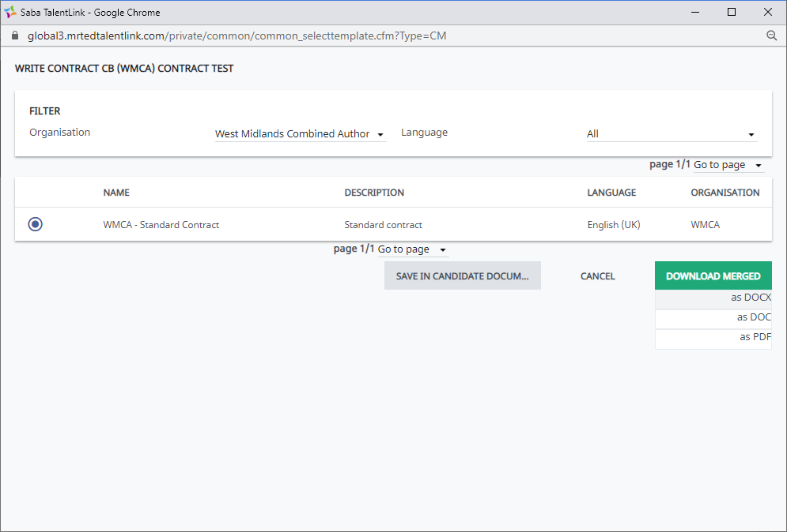
If you download a contract, this will typically work how your local settings our configured – this will appear in your downloads or will show as downloaded in the pop-up window:
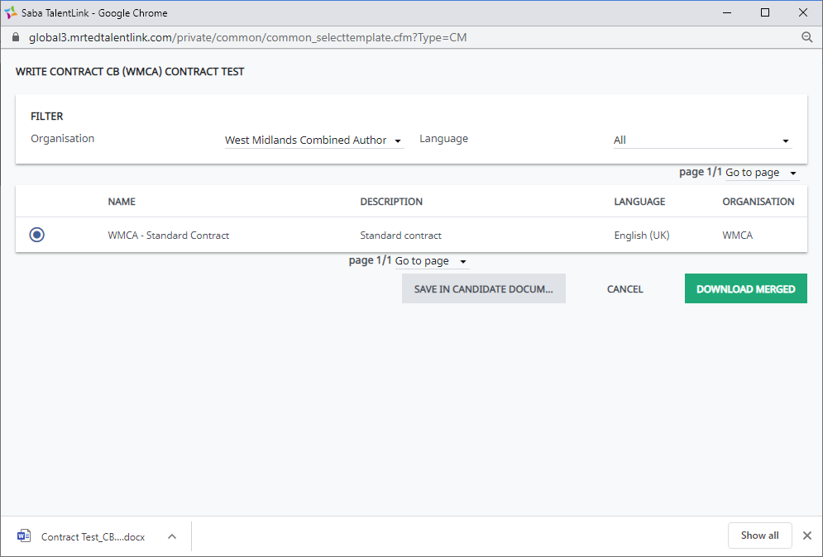
If you select ‘Save in Candidate Documents’, the system will process the request and TalentLink will refresh, taking you to the ‘Document/Candidate Pools’ tab for the candidate where you will see a copy automatically uploaded:
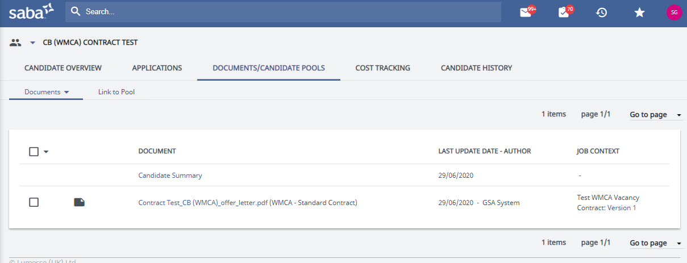
This will then be accessible for you to send to a candidate through the ‘Add a New Document’ functionality on Communication Templates:
This will appear in ‘Select in Candidate File’:
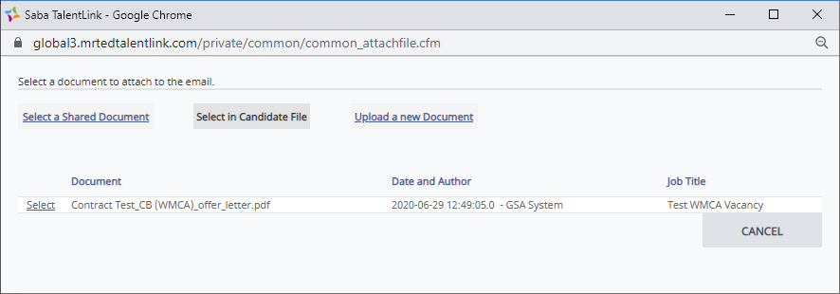

Amending contracts
If you wish to make any changes to your current contracts within TalentLink, for example, add new merge fields or IF statements, you will need to action this differently to how you may have done previously.
How to amend a contract template
As you would previously, you would navigate to Communication Templates and choose your contract template by filtering by the organisation the contract sits under, and selecting the Document/Template Type as MS Word Contract Type:
From the list, click on the name of the contract you wish to amend.
Near the bottom of the screen, you will see an option – Download MS Word document with available merge fields:
Click the icon next to the wording. This will download a ZIP file which will contain a copy of the contract, and also, the data source from TalentLink which will give you the option to add the relevant merge fields from the system:

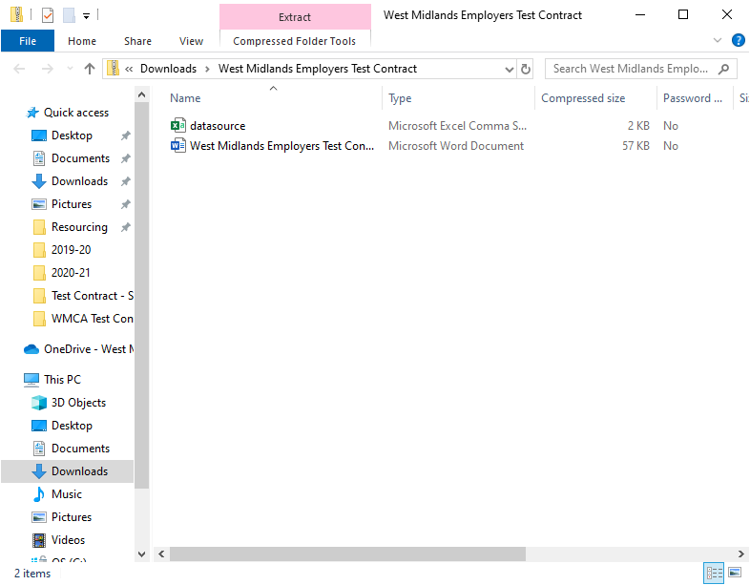

You will need to extract these files where you’ll be given the option to save these files to a folder locally, which can be to a local drive or your desktop – please ensure you do not save and change the name of these documents.
Once you have extracted the files into a local file, click the contract document to open this.
When you open the document, you will see the below dialog box. Select ‘No’:

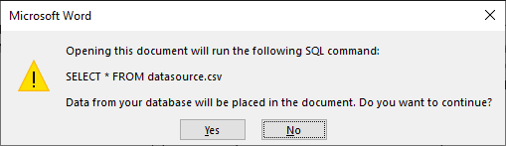

What you then need to do is use the Mail Merge Wizard to link your contract template to the data source which you extracted earlier.
On your Word document, navigate to the Mailings tab, and click the drop-down arrow under Start Mail Merge:
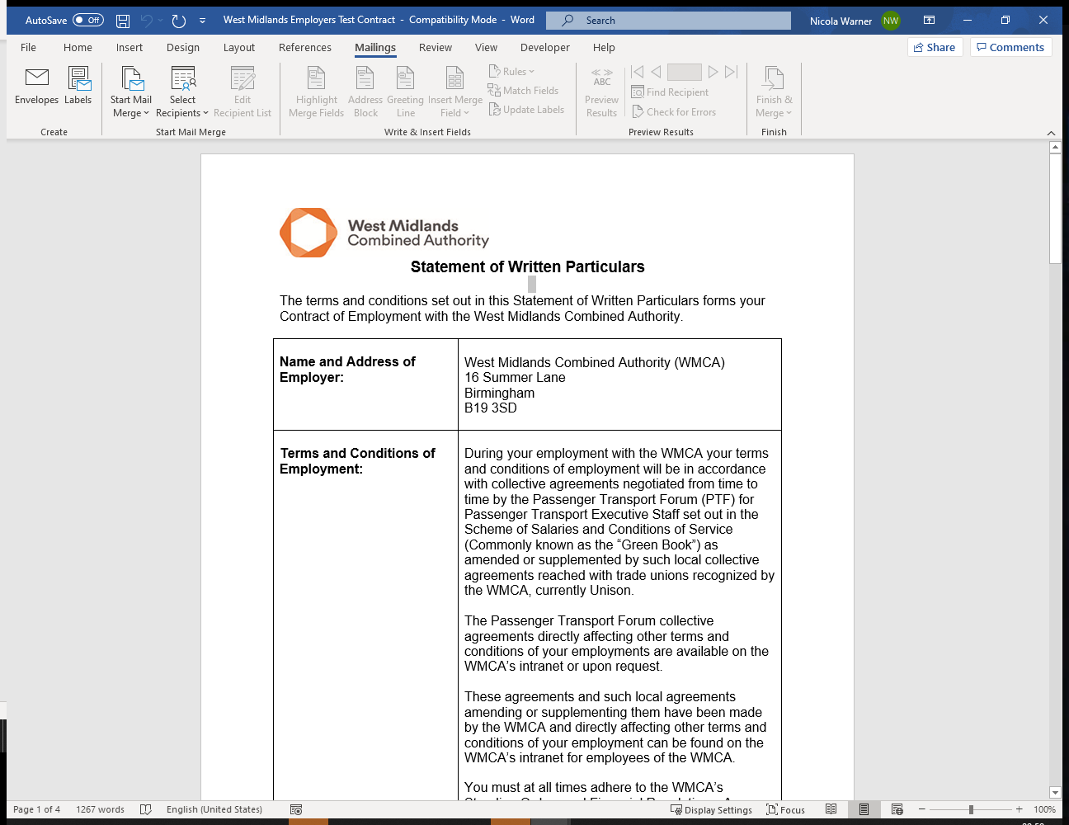
From the options, select Step-by-Step Mail Merge Wizard:
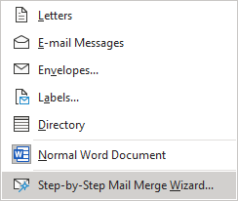
The wizard will then appear to the right of your screen.
At the bottom click Next: Starting document so that you navigate to Step 2 of 6.
Ensure that the starting document is set to Use the current document:
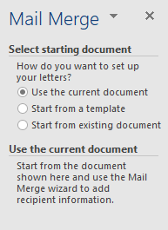
Click Next: Select recipients.
Here, select Browse and choose the datasource from the extracted folder you downloaded earlier:
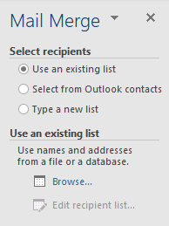

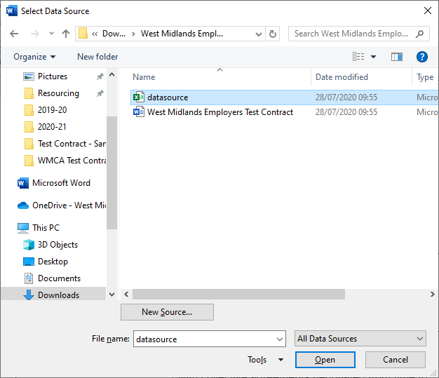

The following dialog box will appear – click Ok:

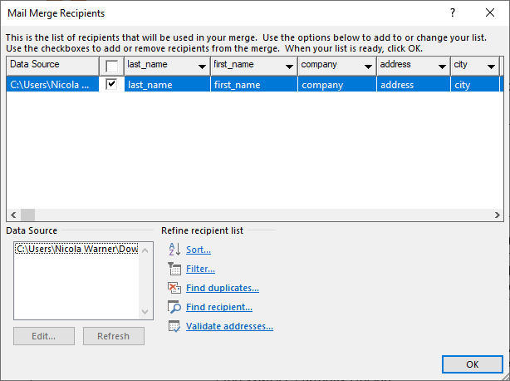

On the document itself, select Alt and F9 and you should see the existing merge fields and IF statements appears on the document.
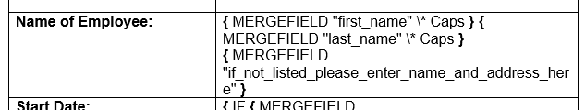

Close the wizard and now you can insert merge fields into the document by clicking the Insert Merge Field option from the Mailings Toolbar:

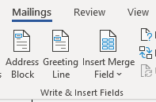
Save the document and re-upload the document into TalentLink.

